Praying with Purpose: Praying in steps

The Bible encourages us to ask with faith. “If you believe, you will receive whatever you ask for in prayer.” Matthew 21:22

But even though we’re assured that if we only have faith as small as a mustard seed then we can move mountains, it’s not always easy to have faith for what seems to us to be big answers to prayer.

A helpful way to pray, then, is to do so in “steps of faith”

Decide what you do have faith for. This may be a very small thing but that’s fine. Pray with the faith you have that God will answer your request.

Once this has happened then decide what your next step in prayer will be –
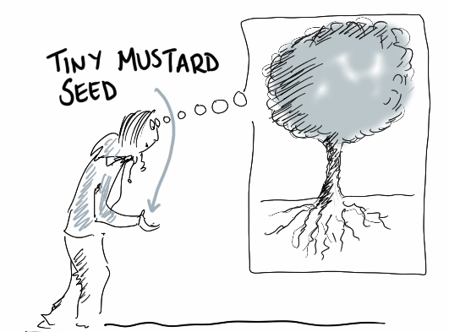
what do you now have faith for?

Once this has been answered then take the next step… and on and
on until the initial need has been met.

You’ll probably find that as each step of prayer is answered
then your faith will grow accordingly.

For example:

The desired outcome may be that a local prison will change their mind and accept the offer of Mothers’ Union to run a crèche for visiting families.

Steps of prayer:

Step one: ask yourselves what you do have faith for e.g. that someone in authority in the prison sees the email containing the proposal and sends an answer back.
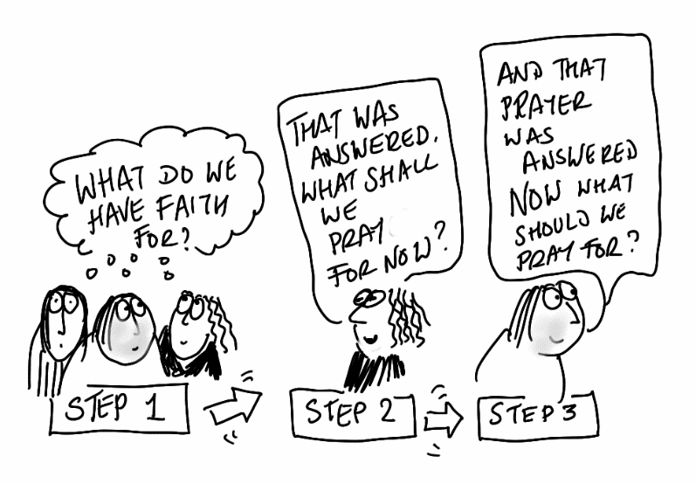
Step two: once this prayer has been answered then decide what the next step in prayer should be e.g. that a meeting be agreed to so that the proposal can be discussed.

Step three: once this prayer has been answered maybe the next prayer step will be for a positive outcome to the meeting…

.. and so the steps move forward until they reach the final answer!

God of miracles
bless our tiny steps in prayer
that mountains may be moved.

God of miracles
take our tiny steps of prayer
and use them to bless your world.
Amen

